988. Smallest String Starting From Leaf
Medium

You are given the root of a binary tree where each node has a value in the range [0, 25] representing the letters 'a' to 'z'.
Return the lexicographically smallest string that starts at a leaf of this tree and ends at the root.
As a reminder, any shorter prefix of a string is lexicographically smaller.
- For example, "ab" is lexicographically smaller than "aba".
A leaf of a node is a node that has no children.

Example 1:
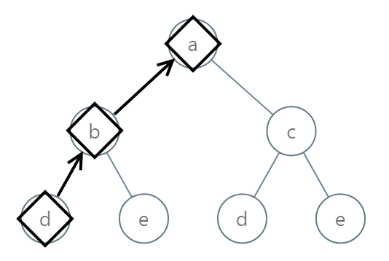
Input: root = [0,1,2,3,4,3,4]
Output: "dba"
Example 2:
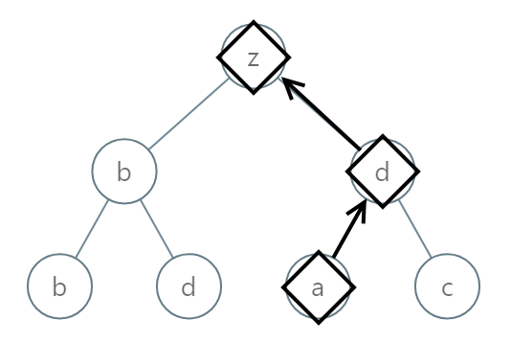
Input: root = [25,1,3,1,3,0,2]
Output: "adz"
Example 3:
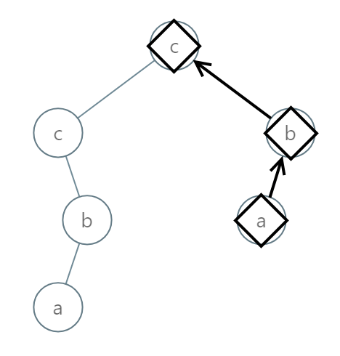
Input: root = [2,2,1,null,1,0,null,0]
Output: "abc"

Constraints:
- The number of nodes in the tree is in the range [1, 8500].
- 0 <= Node.val <= 25

